Photogrammetry and Rapid Documentation at Volubilis, Morocco

Report on an excavations with the Volubilis Archaeological Project (UCL) (INSAP) 25 March-15 April 2018.
Leila Araar

The Moroccan site of Volubilis is known chiefly for its Roman past. However, in the medieval period (late 8th century), it was the early capital of the Idrisids – the first Muslim dynasty independent of any eastern caliphate to rule Morocco. Thus, Volubilis contains abundant evidence of the rise and development of Islam in Morocco. The ‘Volubilis Archaeological Project’ is a joint project between UCL and INSAP (L’Institut National des Sciences de l’Archéologie et du Patrimoine), which aims to investigate this crucial historical period.
The Volubilis Archaeological Project previously uncovered a large medieval town, containing Islamic structures including a mosque, a bath complex, and a number of domestic structures. In 2018, the project resumed after a decade, with particular focus on accurate and detailed recording, facilitated by various modern technologies. Photogrammetry can provide an accurate, high-resolution in-situ record of archaeological excavations. This is especially critical for heritage at risk, such as the many Islamic sites currently in danger of severe damage from either neglect, physical destruction, or terrorist activity. However, photogrammetry has been rarely applied to Islamic sites, effecting a need for a case study. This will allow archaeologists to study the potential of the technology to record current states of sites and the ongoing damage over time, and compare these to past conditions by incorporating historical documents and photographs into their models. It is for this reason that in March 2018 I attended the excavations at Volubilis, planning to gather data and perform photogrammetric surveys of the site. The aims were to focus on the practical use and efficiency of photogrammetry on an archaeological excavation for documentation and interpretation.
During the season, two areas were excavated. Work in Area E focused on reconstructing the site stratigraphy, which was largely destroyed by French excavation in the 1950s. Area A dated to the 8-18th century and served as the focus of the project. Site A contained remains of a domestic Berber structure, which included a collapsed burnt loft. The burnt remains sat atop several cooking pots, incense burners and a large in-situ jar which appeared to have been crushed inside a storage pit by falling debris. This provided me with an opportunity to record the jar and its scattered fragment, facilitating the interpretation of the complex associated stratigraphy.
Unfortunately, otherwise few opportunities for digital recording arose during this season. This was largely due to the time constraints and unfortunate weather during the second half of the season. Nevertheless, parts of the site were recorded digitally, and the grant provided by the Society for Libyan studies also allowed me to attend an excavation which has sparked my interest in Islamic Archaeology and shaped my future studies (I am currently pursuing a Masters degree in Digital Heritage). While I do not have the opportunity to attend the 2019 season, I aim to continue my studies in the use of digital methods in Islamic Archaeology through other projects.
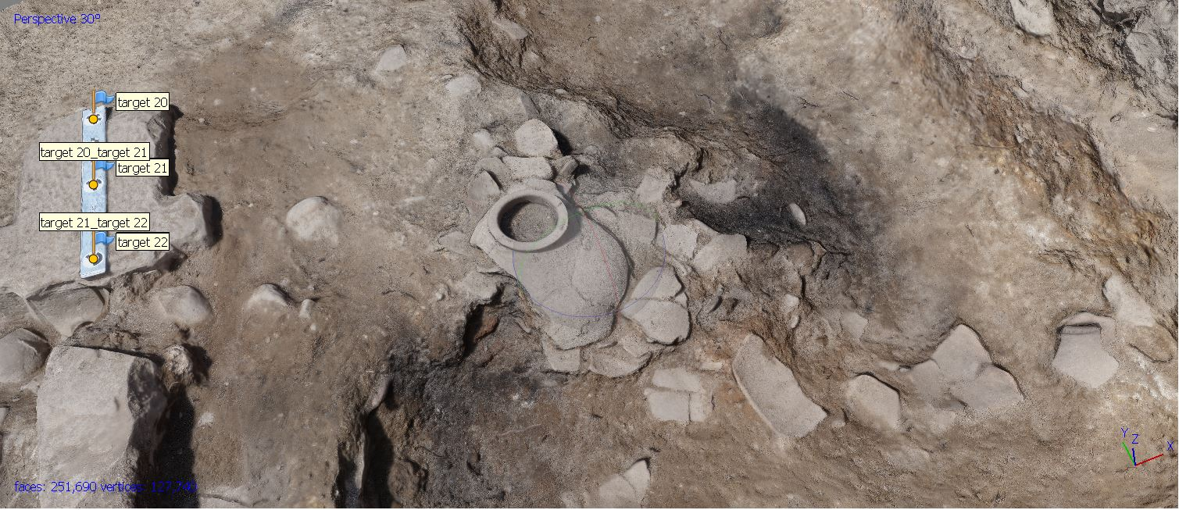

Expenditure
- Return Flight: £237.42
- Excavation Fee (Including accommodation and meals): £600

